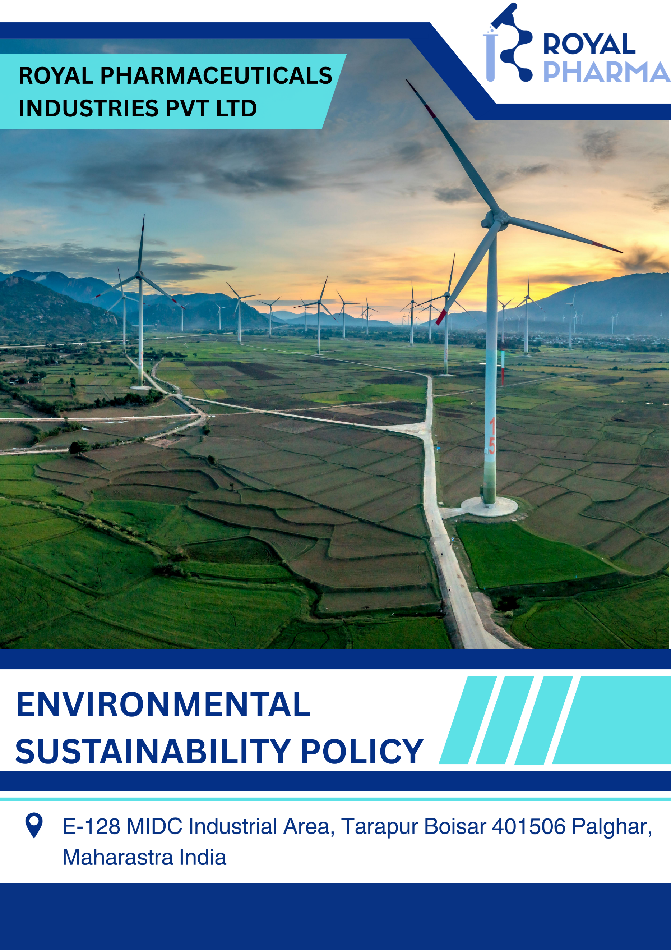

Table of Contents
1. Introduction 3
2. Purpose 3
3. Applicability 3
4. Policy Statement 4
5. Strategic Commitments 4
6. Ownership & Accountability 12
7. Monitoring & Measurement 13
8. Training & Awareness 14
9. Review Mechanism 14
10. Employee Acknowledgement Form 15

Introduction
Royal Pharmaceuticals Industries Pvt. Ltd. recognizes environmental stewardship as a core business responsibility and an essential element of sustainable growth. The Company is committed to integrating environmental sustainability into all aspects of its operations through responsible resource management, pollution prevention, climate action, regulatory compliance, and continual improvement, while minimizing its environmental footprint and supporting the manufacture of safe, high-quality pharmaceutical products.

Purpose
The purpose of this Environmental Sustainability Policy is to establish a structured framework for integrating environmental sustainability into all business operations of Royal Pharmaceuticals Industries Pvt. Ltd. The policy aims to:
- Promote responsible environmental management throughout the Company's operations.
- Minimize adverse environmental impacts associated with manufacturing, utilities, storage, transportation, and support activities.
- Improve energy efficiency and reduce greenhouse gas (GHG) emissions.
- Prevent pollution through responsible management of emissions, effluents, hazardous substances, and waste.
- Protect biodiversity and surrounding ecosystems affected by business operations.
- Strengthen environmental risk management and climate resilience.

Applicability
This Environmental Sustainability Policy applies to the manufacturing facility of Royal Pharmaceuticals Industries Pvt. Ltd. located at E-128, MIDC Industrial Area, Tarapur, Boisar – 401506, Palghar, Maharashtra, India. It applies to all employees, directors, contractors, suppliers, consultants, service providers, and other personnel working on behalf of the Company.

Policy Statement
Royal Pharmaceuticals Industries Pvt. Ltd. is committed to conducting its business in an environmentally responsible manner by integrating sustainable environmental practices into every stage of its operations. The Company believes that environmental protection, responsible manufacturing, operational excellence, and business growth are mutually reinforcing objectives.

Strategic Commitments
- Climate Change Mitigation and Energy Management

Objectives
- We strive to improve energy efficiency across manufacturing operations, utility systems, laboratories, warehouses, and administrative facilities through process optimization and energy-efficient technologies.
- We will work towards reducing Scope 1 and Scope 2 greenhouse gas emissions by improving fuel efficiency, optimizing utility operations, and implementing energy conservation initiatives throughout the manufacturing facility.
- We will explore and progressively increase the adoption of renewable energy sources, such as rooftop solar power and green electricity procurement, wherever technically and commercially feasible.
- We strive to improve the efficiency of boilers, chillers, air compressors, HVAC systems, pumps, motors, and other utility equipment through preventive maintenance and operational optimization.
- We seek to minimize direct greenhouse gas emissions associated with stationary combustion equipment, process operations, and Company-owned vehicles by adopting cleaner operational practices.
- We will identify and assess relevant Scope 3 emission categories, including purchased raw materials, transportation, business travel, waste management, and upstream supply chain activities to better understand and manage the Company's overall carbon footprint.

Targets
- We aim to reduce absolute Scope 1 and Scope 2 and 3 greenhouse gas emissions and GHG Emission intensity by 7% by FY 2029-30, compared to the FY 2025-26 baseline, through energy efficiency improvements and cleaner energy adoption.
- Our goal is to improve energy consumption intensity by 8% by FY 2029-30, compared to the FY 2025-26 baseline, through process optimization and modernization of manufacturing equipment.
- We plan to progressively increase renewable energy utilization and source at least 10% of total electricity consumption from renewable energy by FY 2029-30, compared to FY 2025-26 baseline, subject to technical and commercial feasibility.
- We aim to implement energy-efficient LED lighting across 100% of applicable operational areas by FY 2029-30, compared to the FY 2025-26 infrastructure status.
- We will ensure 100% annual monitoring and reporting of Scope 1 and Scope 2 greenhouse gas emissions and progressively expand Scope 3 emissions assessment for relevant categories.
- We aim to conduct annual energy performance assessments covering 100% of significant energy-consuming equipment to identify and implement improvement opportunities.
- Water Stewardship

Objectives
- We strive to optimize water consumption across manufacturing processes, utility operations, laboratories, sanitation facilities, and other operational areas through efficient water management practices.
- We will work towards minimizing freshwater consumption by implementing water conservation initiatives, process improvements, and preventive maintenance activities.
- We seek to maximize opportunities for water recycling and reuse through appropriate treatment systems and operational improvements wherever technically feasible.
- We strive to prevent water pollution by ensuring proper operation of wastewater treatment facilities and maintaining compliance with applicable discharge standards.
- We will conduct periodic inspections of pipelines, storage tanks, valves, cooling systems, and other water distribution infrastructure to identify and eliminate water leakages.
- We will evaluate water-efficient technologies and process improvements during equipment replacement, facility expansion, and new capital projects.
- We encourage suppliers and contractors to support responsible water management practices while conducting activities within the Company's premises.

Targets
- We aim to reduce freshwater consumption intensity by 20% by FY 2029-30, compared to the FY 2025-26 baseline.
- Our goal is to increase water recycling and reuse to at least 30% of total operational water consumption by FY 2029-30, compared to FY 2025-26 baseline, subject to technical feasibility.
- We will ensure 100% monitoring of water consumption across significant operational areas on an annual basis.
- We aim to maintain 100% compliance with applicable wastewater discharge standards and environmental permit requirements each year.
- We strive to detect and rectify 100% of identified water leakages within defined corrective action timelines.
- We plan to install water-efficient fixtures and conservation devices in 100% of applicable operational areas by FY 2029-30, compared to the FY 2025-26infrastructure status.
- Biodiversity Conservation

Objectives
- We will protect and maintain greenbelt areas within the manufacturing premises to enhance local biodiversity and improve environmental quality.
- We will encourage plantation of native and climate-resilient plant species within the Company's premises wherever practicable.
- We strive to prevent soil, water, and air contamination that could adversely affect biodiversity through effective environmental management practices.
- We will promote biodiversity awareness among employees through environmental campaigns, plantation drives, and sustainability initiatives.

Targets
- We aim to maintain and enhance greenbelt coverage within the manufacturing premises by undertaking annual plantation programs through FY 2029–30, compared to the FY 2025-26 baseline.
- Our goal is to achieve 100% compliance with applicable environmental, forest, wildlife, and land-use regulations each year.
- We plan to conduct at least one biodiversity conservation or tree plantation initiative annually through FY 2029–30.

- Air Quality Management

Objectives
- We strive to minimize air pollutant emissions from manufacturing processes, boilers, DG sets, utilities, and other operational activities through effective emission control measures and process optimization.
- We will continuously improve air quality management by adopting cleaner technologies, preventive maintenance programs, and efficient operational practices wherever technically and economically feasible.
- We seek to reduce emissions of particulate matter (PM), Sulphur Oxides (SOx), nitrogen oxides (NOx), volatile organic compounds (VOCs), and other regulated air pollutants through appropriate engineering and operational controls.
- We will maintain air pollution control equipment in effective working condition through periodic inspection, calibration, preventive maintenance, and timely replacement where required.
- We strive to monitor ambient air quality and stack emissions at prescribed intervals to evaluate environmental performance and ensure compliance with statutory requirements.
- We seek to prevent fugitive emissions from chemical storage, material handling, solvent transfer, and manufacturing operations through appropriate containment and operational controls.

Targets
- We aim to maintain 100% compliance with applicable statutory limits for stack emissions and ambient air quality throughout FY 2029–30, compared to the FY 2025-26baseline.
- We strive to reduce particulate matter (PM) emissions from applicable emission sources by 15% by FY 2029–30, compared to the FY 2025-26 baseline, through operational improvements and emission control measures.
- We plan to reduce emissions of NOx and SOx from combustion sources by 10% by FY 2029–30, compared to the FY 2025-26 baseline, wherever technically feasible.
- We will conduct 100% scheduled stack emission and ambient air quality monitoring in accordance with applicable legal and permit requirements each year.
- We strive to maintain zero significant regulatory non-compliances related to air emissions throughout the policy period.

- Sustainable Materials and Resource Management

Objectives
- We strive to optimize the consumption of raw materials, chemicals, solvents, and packaging materials through process optimization and efficient resource management.
- We will promote the responsible procurement, storage, handling, transportation, and use of chemicals to minimize environmental risks and ensure operational safety.
- We seek to reduce waste generation at source by adopting cleaner production techniques, process improvements, and material recovery initiatives.
- We will maximize opportunities for waste segregation, reuse, recycling, recovery, and responsible disposal in accordance with applicable legal and regulatory requirements.
- We strive to strengthen hazardous waste management by ensuring proper identification, storage, labelling, handling, transportation, and disposal through authorized recyclers and disposal facilities.
- We will promote solvent recovery, chemical recovery, and resource conservation initiatives wherever technically and economically feasible to reduce environmental impacts.
- We seek to prevent accidental spills, leaks, and chemical releases through effective operational controls, preventive maintenance, emergency preparedness, and employee awareness.

Targets
- We strive to reduce hazardous waste generation by 10% by FY 2029–30, compared to the FY 2025-26 baseline, wherever technically feasible.
- We will ensure 100% disposal of hazardous waste through CPBC/MPCB authorized recyclers, co-processors, or Treatment, Storage and Disposal Facilities (TSDFs) each year.
- We aim to increase the recycling and recovery of non-hazardous waste to at least 75% by FY 2029–30, compared to the FY 2025-26 baseline.
- We strive to maintain 100% compliance with applicable regulations governing chemical management, hazardous waste, and non-hazardous waste management each year.
- We aim to maintain zero major environmental incidents resulting from chemical spills, hazardous waste handling, or improper waste disposal throughout the policy period.

- Sustainable Product Design and End-of-Life Management

Objectives
- We strive to integrate environmental considerations throughout the product lifecycle by promoting responsible product stewardship from manufacturing to end-of-life management.
- We will provide customers with appropriate information on the safe handling, storage, transportation, use, and disposal of products and packaging materials, where applicable.
- We seek to optimize product packaging by encouraging the use of recyclable, reusable, or environmentally preferable packaging materials without compromising product quality, safety, or regulatory compliance.
- We will continuously evaluate opportunities to reduce packaging waste and improve material efficiency through sustainable packaging initiatives.
- We strive to ensure that product labels, Safety Data Sheets (SDS), technical documents, and regulatory information support the environmentally responsible use and disposal of our products.
- We will encourage customers, distributors, and supply chain partners to adopt environmentally responsible practices for managing product packaging and applicable end-of-life materials.

Targets
- We aim to ensure 100% of applicable products are supplied with accurate labels, Safety Data Sheets (SDS), and product handling, storage, and disposal information by FY 2029–30, compared to the FY 2025-26 baseline.
- We strive to reduce packaging material consumption intensity by 15% by FY 2029–30, compared to the FY 2025-26 baseline, through packaging optimization initiatives.
- We plan to increase the use of recyclable or environmentally preferable packaging materials to 50% of applicable packaging by FY 2029–30, compared to the FY 2025-26 baseline, wherever technically and commercially feasible.
- We will conduct annual reviews of 100% of applicable product labels and environmental information to ensure compliance with applicable regulatory and customer requirements.
- We strive to maintain 100% compliance with applicable environmental and product stewardship regulations related to product packaging, labelling, transportation, and customer information each year.

- Customer Well-Being & Safety

Objectives
- We strive to manufacture and supply pharmaceutical products that meet applicable quality, safety, environmental, and regulatory requirements while protecting customer health and well-being.
- We will maintain robust quality management systems and Good Manufacturing Practices (GMP) to ensure product integrity, consistency, traceability, and regulatory compliance.
- We seek to provide customers with accurate product information, including product labels, Safety Data Sheets (SDS), Certificates of Analysis (CoA), storage conditions, handling instructions, and other applicable technical documentation.
- We will continuously strengthen product quality assurance, contamination prevention, and product traceability systems to minimize risks throughout the manufacturing and supply chain processes.
- We strive to promptly investigate customer complaints, product quality concerns, and safety-related issues, implementing appropriate corrective and preventive actions to prevent recurrence.
- We will encourage continuous improvement in manufacturing processes, quality control systems, and product stewardship practices to enhance customer confidence and product safety.

Targets
- We aim to maintain 100% compliance with applicable product quality, customer safety, GMP, and regulatory requirements throughout FY 2029–30, compared to the FY 2025-26 baseline.
- We strive to achieve 100% batch traceability for all manufactured products through documented batch manufacturing, testing, and distribution records.
- We will ensure 100% of applicable products are supplied with compliant labels, Certificates of Analysis (CoA), Safety Data Sheets (SDS), and product handling and storage information by FY 2029–30, compared to the FY 2025-26 baseline.
- We aim to investigate and close 100% of customer complaints and product quality incidents within the Company's defined timelines each year.
- We strive to maintain zero critical product recalls resulting from manufacturing defects, contamination, or environmental non-compliance throughout the policy period.
- We will conduct documented quality, safety, and compliance verification for 100% of production batches prior to product release.
- We aim to provide annual GMP, product quality, customer health, and product safety training to 100% of relevant employees by FY 2029–30, compared to the FY 2025-26 baseline.
- Climate Change Adaptation & Resilience

Objectives
- We strive to identify and assess climate-related physical and transition risks that may affect our manufacturing operations, infrastructure, utilities, supply chain, and business continuity.
- We will integrate climate change considerations into strategic planning, capital investments, operational decision-making, and environmental risk management processes.
- We seek to strengthen the resilience of manufacturing facilities and critical infrastructure against climate-related events such as extreme heat, flooding, heavy rainfall, storms, water scarcity, and power disruptions.
- We strive to improve the resilience of our supply chain by engaging suppliers and service providers on climate-related risks and sustainable business practices.
- We will promote climate awareness among employees through training, communication, and participation in climate resilience initiatives.

Targets
- We aim to conduct climate change risk and vulnerability assessments covering 100% of manufacturing operations by FY 2029–30, compared to the FY 2025-26 baseline.
- We will establish and maintain a documented Business Continuity Plan (BCP) and Climate Risk Management Plan covering 100% of critical business operations by FY 2029–30.
- We strive to conduct at least one climate emergency preparedness and business continuity drill annually through FY 2029–30.
- We will integrate climate-related risk assessments into 100% of significant infrastructure expansion and capital investment projects by FY 2029–30.
- We strive to provide annual climate change awareness and emergency preparedness training to 100% of relevant employees by FY 2029–30, compared to the FY 2025-26 baseline.
- Sustainable Resource Use & Circular Economy

Objectives
- We strive to optimize the use of raw materials, packaging materials, utilities, and other natural resources through efficient manufacturing processes and responsible resource management.
- We will promote circular economy principles by encouraging the reduction, reuse, recovery, and recycling of materials wherever technically and economically feasible.
- We seek to improve resource productivity by implementing process optimization, lean manufacturing practices, and continuous improvement initiatives across our operations.
- We will evaluate opportunities to utilize recycled, recovered, renewable, or environmentally preferable materials in manufacturing and packaging without compromising product quality, safety, or regulatory compliance.
- We strive to reduce the consumption of virgin raw materials by promoting material efficiency, inventory optimization, and responsible procurement practices.
- We will encourage suppliers, contractors, and business partners to adopt sustainable resource management practices and support the Company's environmental sustainability objectives.

Targets
- We aim to improve overall resource utilization efficiency by 20% by FY 2029–30, compared to the FY 2025-26 baseline, through process optimization and operational improvements.
- We strive to reduce virgin raw material consumption intensity by 10% by FY 2029–30, compared to the FY 2025-26 baseline, wherever technically feasible.
- We plan to increase the utilization of recycled, recovered, or environmentally preferable materials to 20% of applicable material consumption by FY 2029–30, compared to the FY 2025-26 baseline.
- We aim to reduce paper consumption by 60% by FY 2029–30, compared to the FY 2025-26 baseline, through digitalization and electronic document management.
- We will ensure 100% segregation of recyclable and recoverable materials at designated collection points throughout the manufacturing facility each year.
- We strive to divert at least 80% of recyclable non-hazardous waste from landfill through recycling and recovery initiatives by FY 2029–30, compared to the FY 2025-26 baseline.
- We will provide annual resource conservation and circular economy awareness training to 100% of relevant employees by FY 2029–30, compared to the FY 2025-26 baseline.

Ownership & Accountability
Managing Director
The Managing Director is responsible for approving the Environmental Sustainability Policy and providing strategic direction for environmental sustainability across the Company. The Managing Director shall demonstrate leadership and commitment towards environmental protection and sustainable manufacturing, ensure the availability of adequate financial, technical, and human resources for policy implementation, and periodically review environmental performance, objectives, and strategic targets.
Department Heads
Department Heads are responsible for implementing the Environmental Sustainability Policy within their respective departments. They shall integrate environmental objectives into departmental operational plans, identify environmental risks, opportunities, and improvement initiatives, and ensure compliance with applicable environmental legislation and internal procedures.
EHS Coordinator
The EHS Coordinator shall coordinate the implementation and periodic review of the Environmental Sustainability Policy. Responsibilities include developing environmental objectives, programs, and Key Performance Indicators (KPIs), maintaining environmental records, statutory documentation, and performance reports, and conducting environmental awareness programs while providing technical guidance to all relevant departments.
Quality Assurance & Quality Control
The Quality Assurance and Quality Control functions shall ensure that environmental considerations are integrated into manufacturing and quality management systems wherever applicable. They are also responsible for verifying compliance with applicable environmental, quality, and regulatory requirements.
Procurement & Supply Chain
The Procurement and Supply Chain function shall promote environmentally responsible procurement practices during supplier selection and evaluation. It shall encourage suppliers and contractors to comply with the Company's environmental expectations and procure environmentally preferable products and services wherever technically and commercially feasible.
Employees
All employees are responsible for complying with this Environmental Sustainability Policy and applicable environmental procedures. They shall use energy, water, chemicals, and other resources responsibly, follow safe work practices to prevent pollution and minimize waste generation, and actively participate in environmental training, awareness programs, audits, and continual improvement initiatives.

Monitoring & Measurement
Royal Pharmaceuticals Industries Pvt. Ltd. shall regularly monitor, measure, and evaluate its environmental performance to ensure compliance with this Policy, achieve established environmental objectives, and drive continual improvement.
Environmental performance shall be monitored through the following activities:
- Monitoring of Key Performance Indicators (KPIs) against established objectives and targets.
- Periodic measurement of energy consumption, greenhouse gas emissions, water consumption, air emissions, wastewater quality, and waste generation.
- Compliance monitoring against applicable legal, regulatory, and permit requirements.
- Maintenance of environmental records, monitoring reports, and statutory documentation to demonstrate performance and compliance.

Training & Awareness
Royal Pharmaceuticals Industries Pvt. Ltd. is committed to strengthening environmental awareness and competency across its workforce.
The Company shall provide periodic training and awareness programs on environmental management, pollution prevention, resource conservation, waste management, chemical handling, and applicable legal requirements. Specialized training shall be provided to employees whose activities have significant environmental impacts.

Review Mechanism
The Environmental Sustainability Policy shall be reviewed at least annually, or earlier if required due to changes in legal requirements, business operations, or organizational needs. The review done by the EHS Head and any revisions shall be approved by the Managing Director or the designated management representative before implementation.
Next Review Date: 01st April 2027
Approved By

Managing Director

Employee Acknowledgement Form
I acknowledge that I have received, read, and understood the Environmental Sustainable Framework of Royal Pharmaceuticals Industries Pvt. Ltd.
I understand the Company's commitment to environmental protection, pollution prevention, sustainable resource management, regulatory compliance, and continual improvement. I agree to comply with the requirements of this Policy and perform my duties in a manner that supports the Company's environmental objectives and sustainability commitments.
I further acknowledge that I am responsible for:
- Complying with the Environmental Policy and applicable environmental procedures.
- Using natural resources, energy, water, chemicals, and materials responsibly during my work activities.
- Preventing pollution and minimizing waste generation wherever possible.
- Reporting environmental incidents, unsafe conditions, spills, leaks, or non-compliance to my supervisor or the EHS/ESG Department without delay.
- Participating in environmental training, awareness programs, and continual improvement initiatives organized by the Company.
Employee Declaration
I hereby confirm that I have read, understood, and agree to comply with the Environmental Policy of Royal Pharmaceuticals Industries Pvt. Ltd.
Employee Name
Department
Signature
Date

